CUSTOMER
LOGO HERE 

X-Ray – instructions for UAT

Info about X-Ray 3
Preparation for UAT 3
Create test cases 6
Testing according to prepared test cases 10
Monitoring of progress and results 13

Info about X-Ray

X-Ray is a Test management tool for Jira, it allows creating test cases, effective test planning and tracking test execution directly in Jira project. It is already installed in Pricefx Jira, so no special configuration is needed from Cargill team.

Preparation for UAT

Create test plan for UAT
- Example: https://pricefx.atlassian.net/browse/C4CARGL-507

Create test executions – one for every tester – assign them to testers
- Examples: https://pricefx.atlassian.net/browse/C4CARGL-508, https://pricefx.atlassian.net/browse/C4CARGL-509, https://pricefx.atlassian.net/browse/C4CARGL-510

Open Test Plan and add created Test Executions to the test plan for UAT

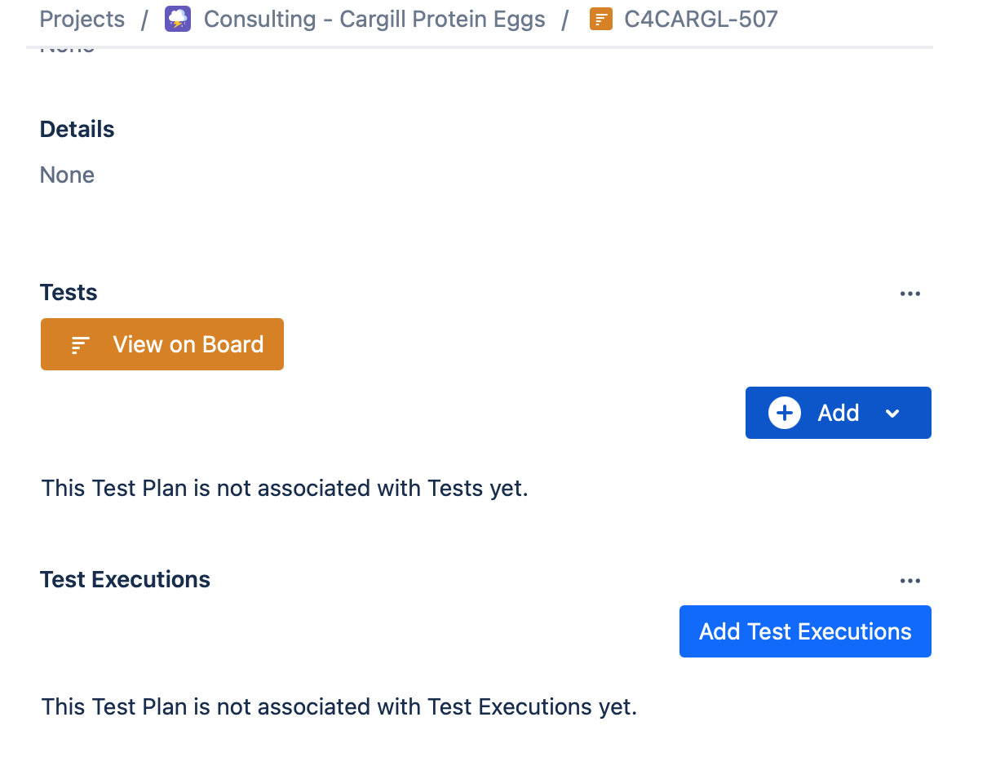
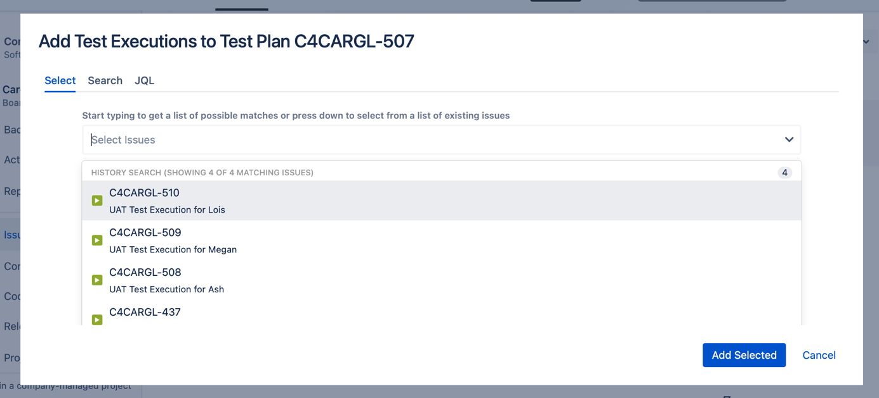

Click on Testing Board and create structure of directories in Test Repository

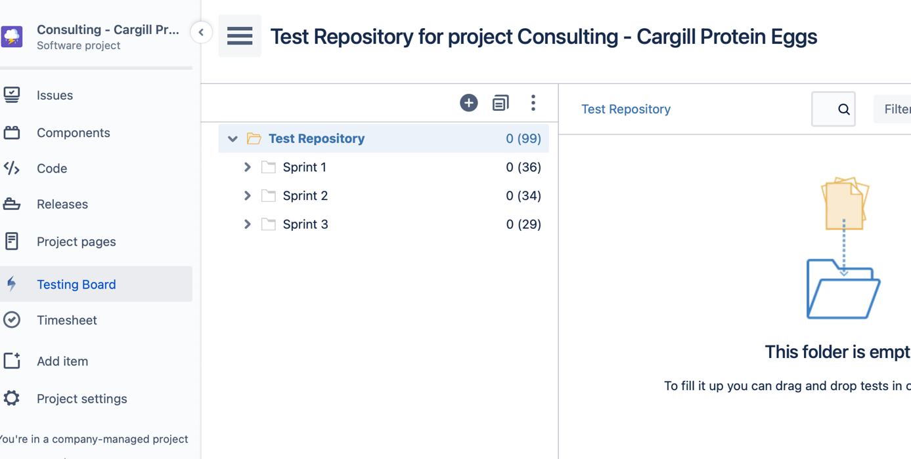

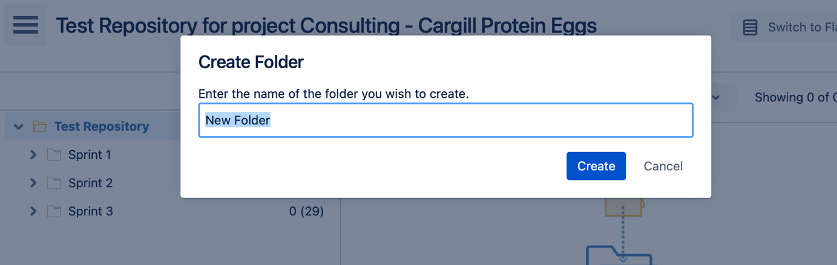

Structure for UAT could look like:

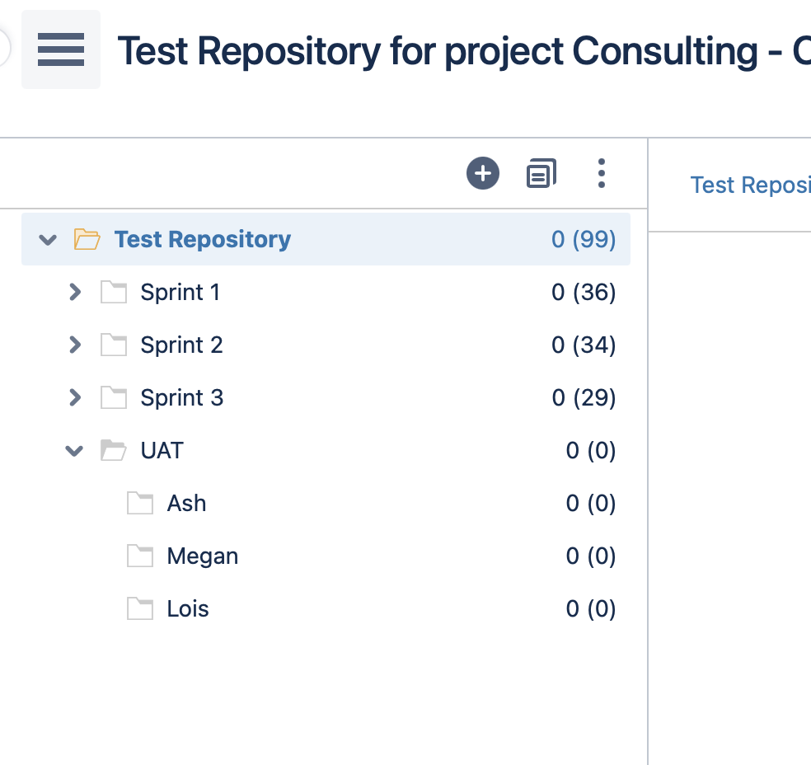

Create test cases

Open User Story

Create test case from the user story (issue type Test)

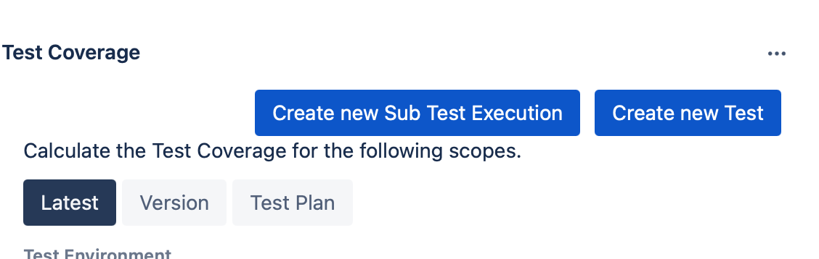

Write instructions to Description – good is also add UAT prefix to Summary

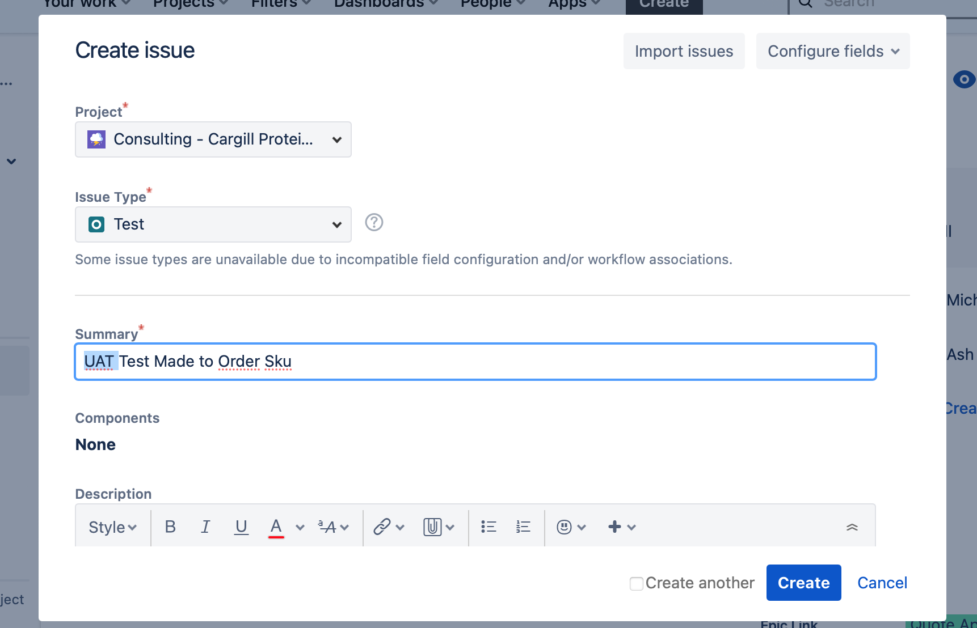

Tests can look like this example:
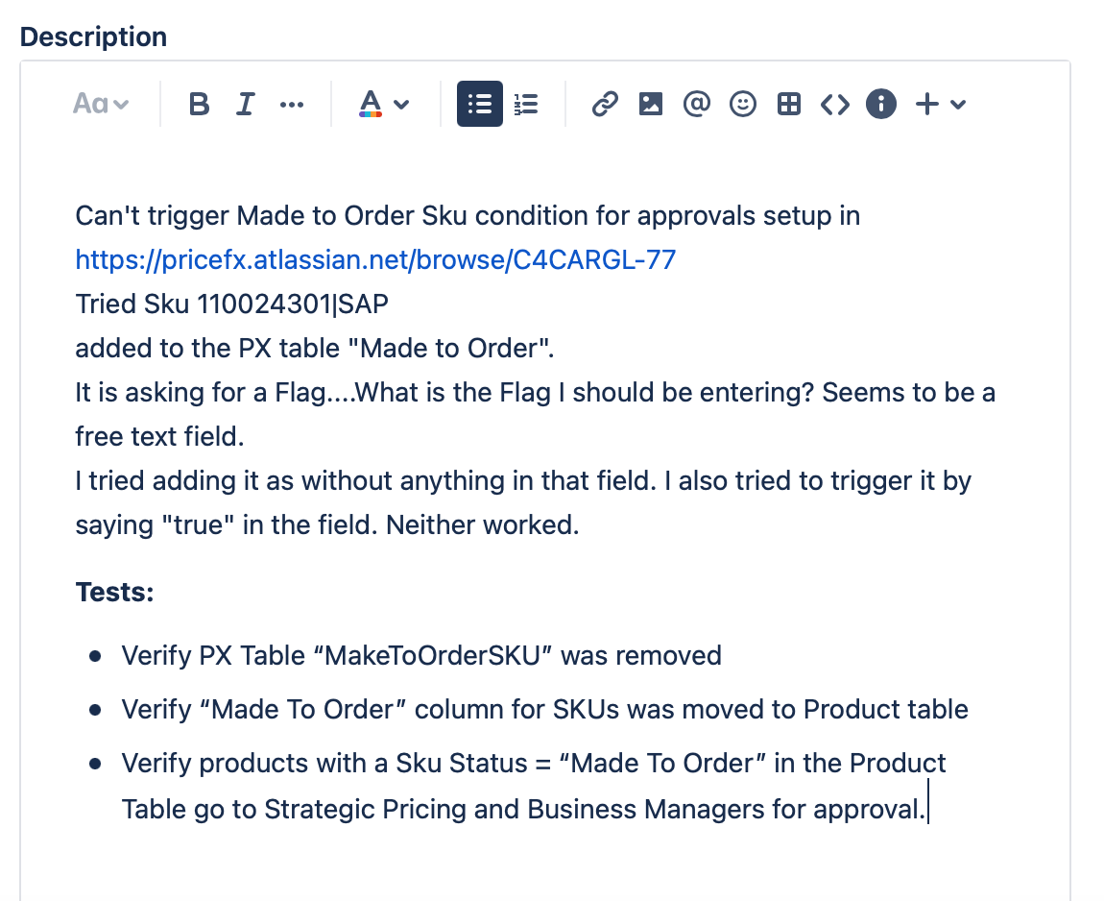

Open Testing Board and in Test Repository click on the right directory

Open menu (right click) – choose Add Tests and choose created test you want to add

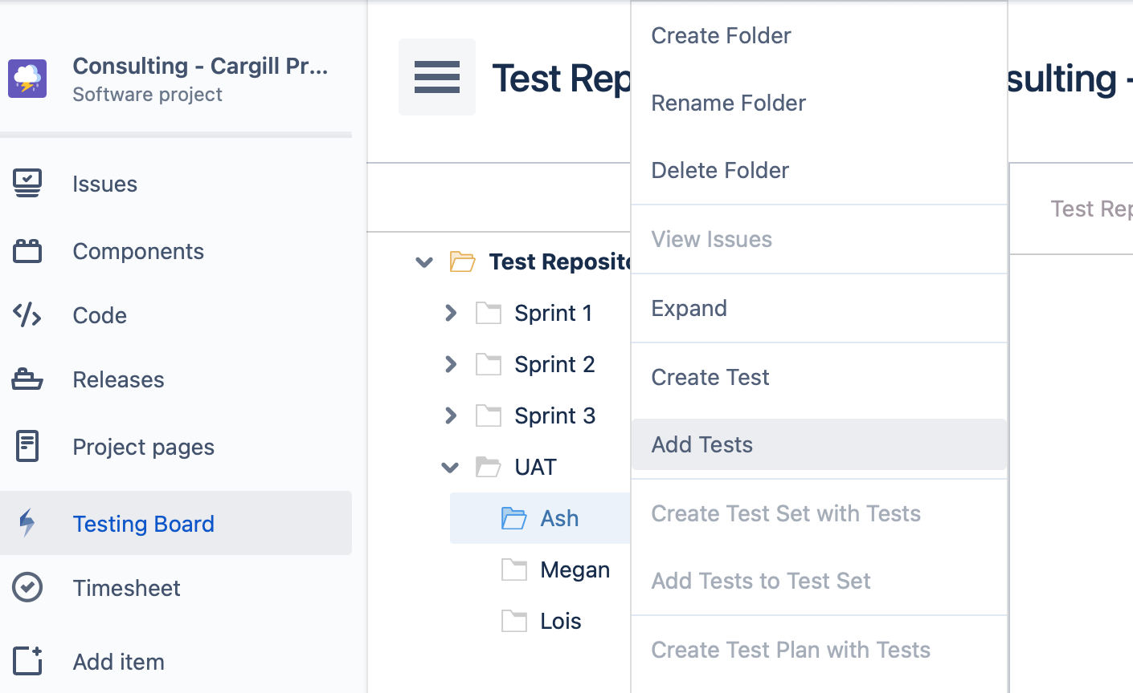

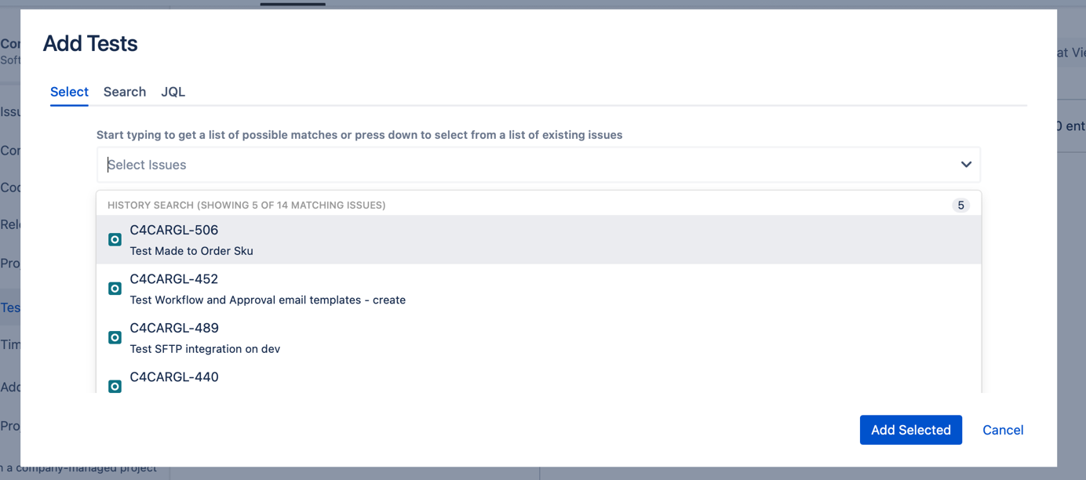

Click on UAT repository

Open menu (right click) – choose Add Tests to Test Plan
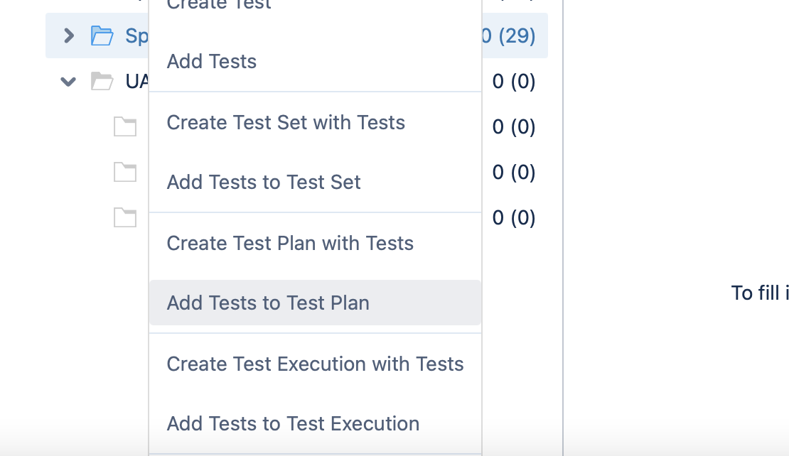

Click on every directory in UAT and click on Add Tests to Test Execution – always choose the right Test Execution for the right tester

Testing according to prepared test cases

Choose Test Execution task assigned to you

Scroll down and choose test case you will test from list of test cases assigned to you – click on the link on the left

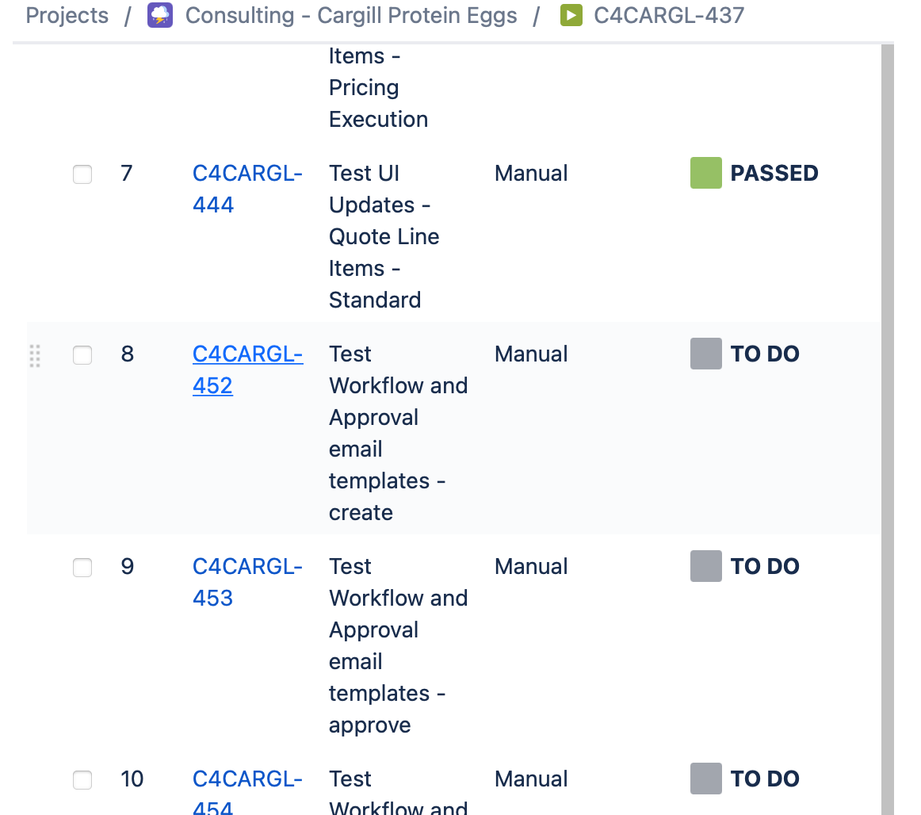

Scroll down to Test Runs section
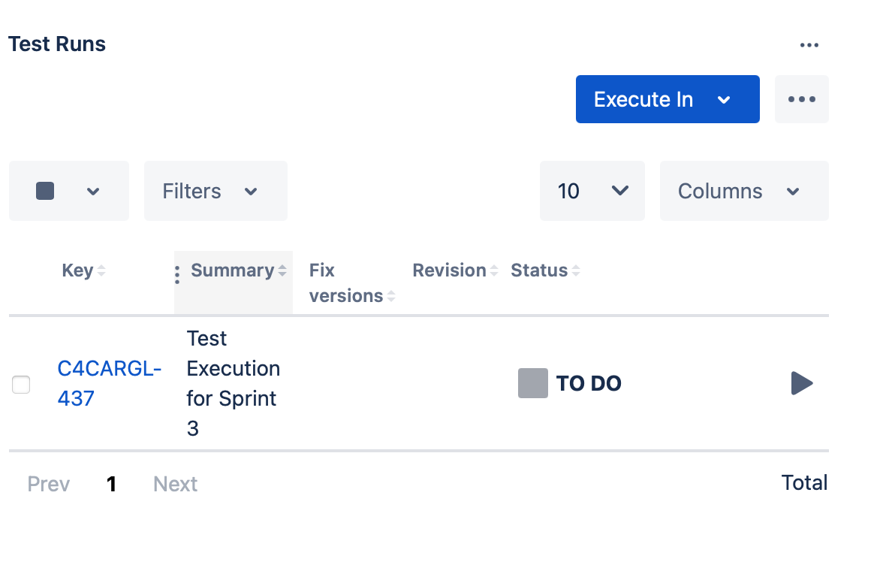

Click on icon on the right


Report test result, create a new bug if needed

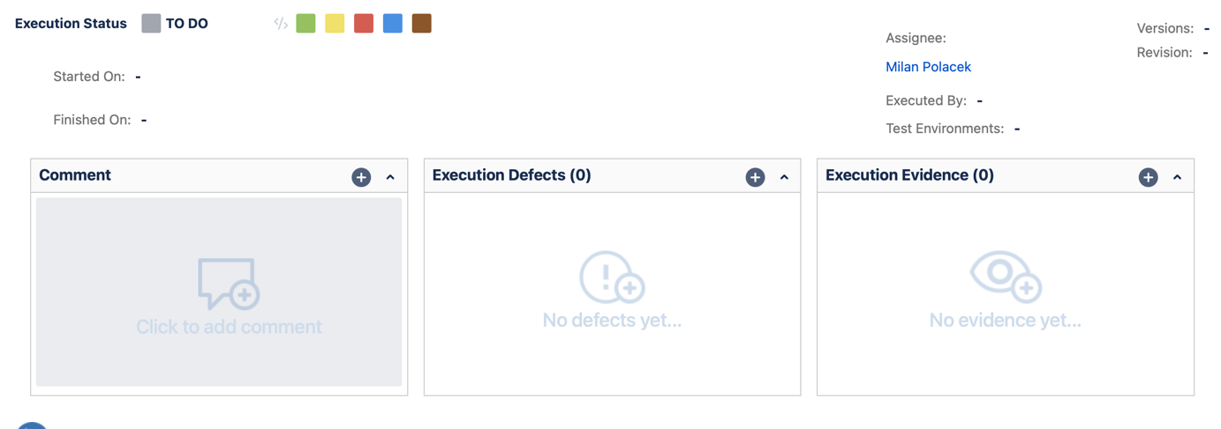

Mark the test as Passed or Failed


Choose the next test from your Test Execution – you can use buttons at the top of the form


Monitoring of progress and results

Open Test Plan for UAT

Scroll down and check Overall Execution Status in the test plan – this gives you high level information about current testing status

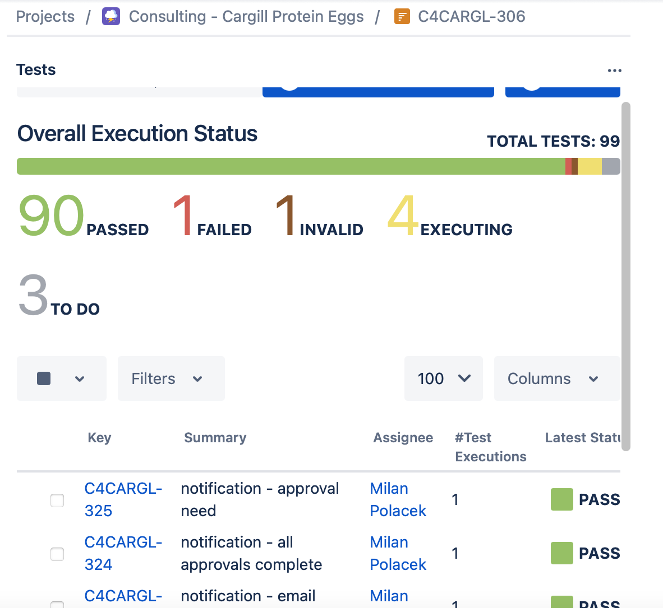

Check Test Executions for testers and evaluate current results – below Overall Status

