Steps to follow to set up Cypress for your projects

- Login into gitlab and go to your project repository
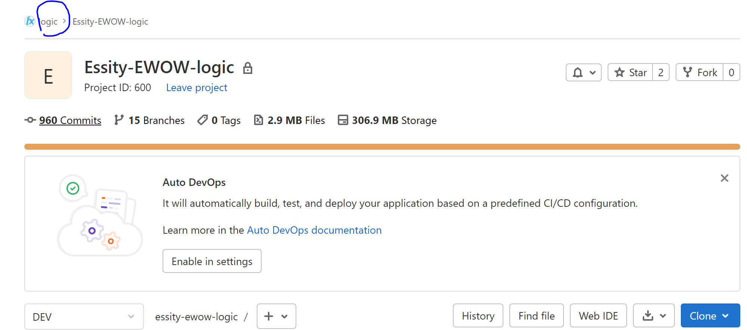
- Create a new Branch under Dev or Master in your project
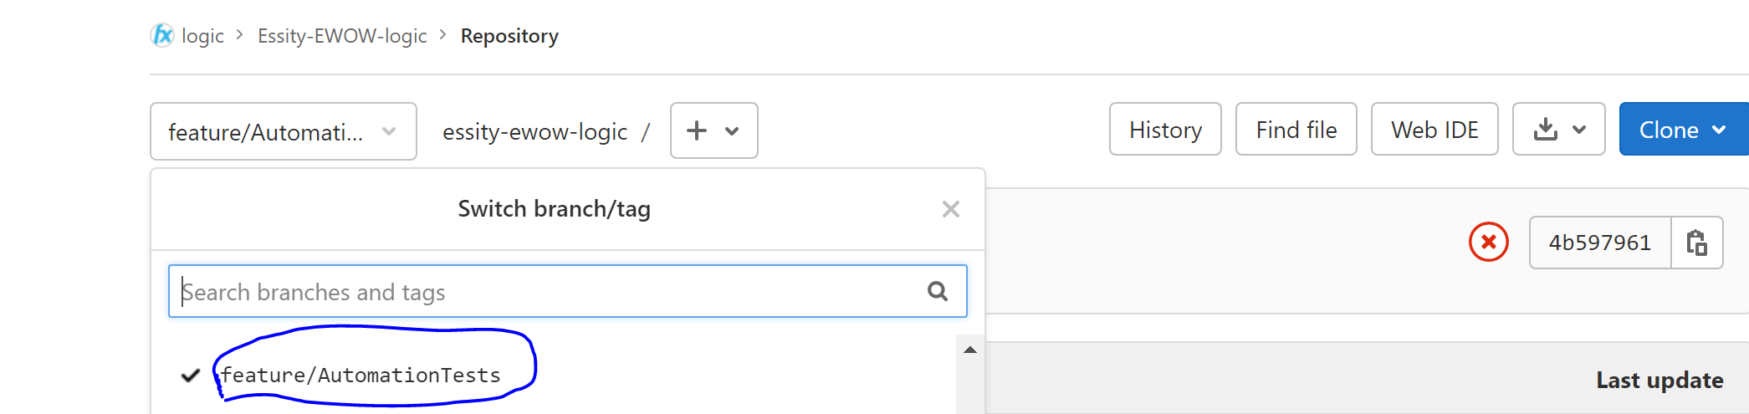
- Set up the cypress first in your local and later could be pushed into git
- Clone the cypress folder from the repository https://gitlab.pricefx.eu/logic/qa-training-logic into your local
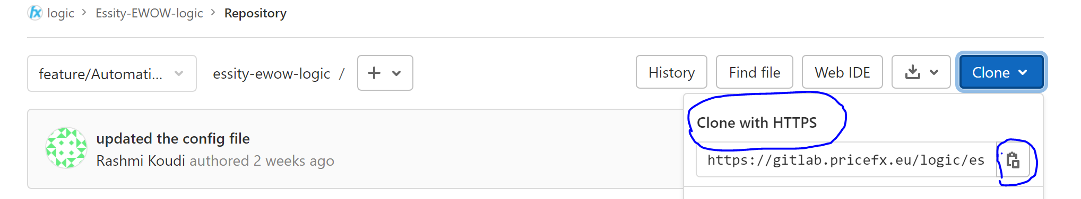
- Visual Studio Code editor is used to write and run the tests locally first.
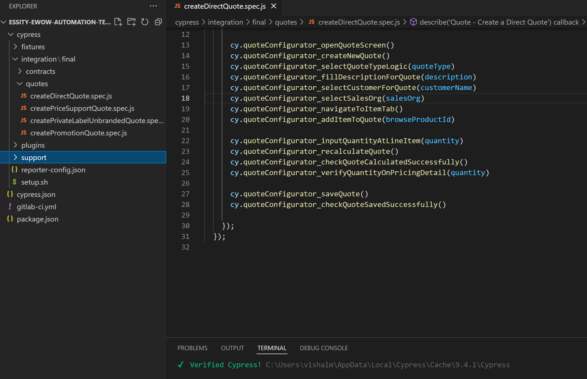
- To get started, these files need to be updated
- cypress.json
- fixtures/testUsersUtils.js
- delete last row in support/index.js (if needed only)
- delete import 'cypress-file-upload'; from support/commands.js
- Create a new test with just login and check if it works and you are able to login to the required partition. Run (npx cypress open) command from the terminal
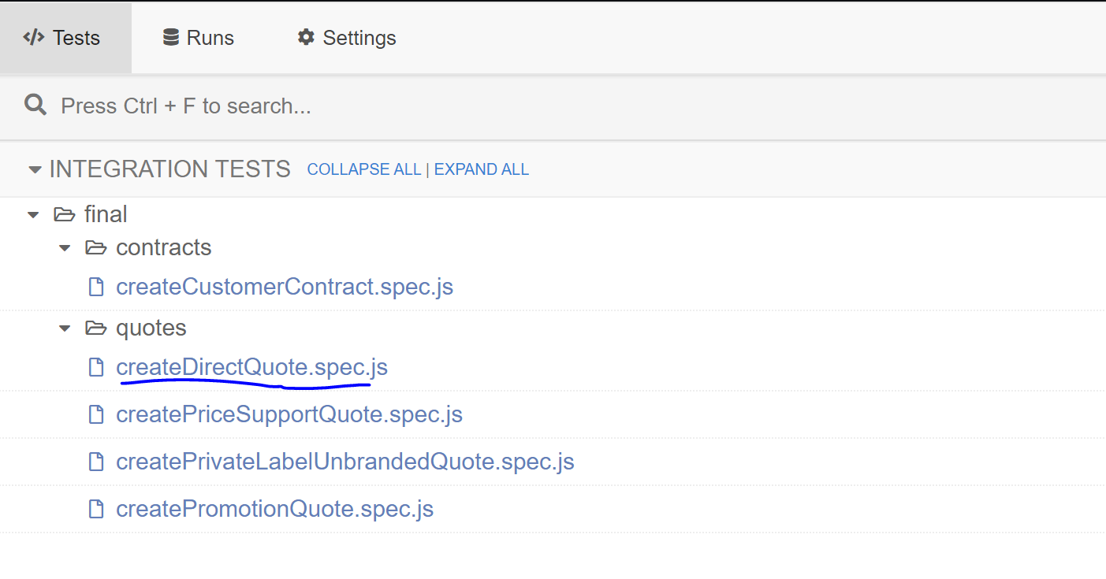
- Push the cypress folder and the other updated config files cypress.json, package.json and .gitlab-ci.yml into the new Branch created in git repo
- Make sure Gitlab CI/CD pipeline is enabled in your project.
- On the top bar, select Menu > Projects and find your project.
- On the left sidebar, select Settings > General.
- Expand Visibility, project features, permissions.
- In the Repository section, turn on or off CI/CD as required.
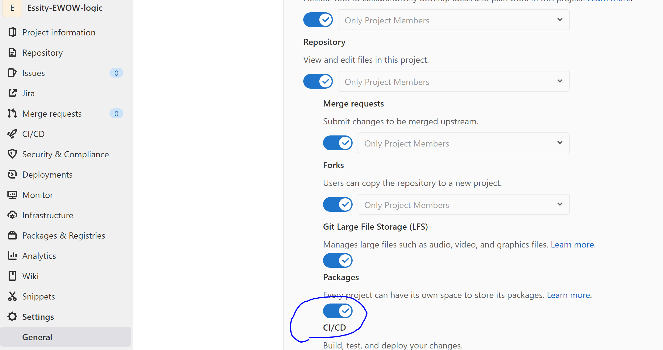
- Add new variables to hold username, password and partition details. As its not secure to store the credentials in the code and connect these variables in gitlab to testUserUtils file
- Create a new pipeline and you can ‘Run pipeline’ whenever needed. Or a job could be scheduled to run your tests at regular intervals.

